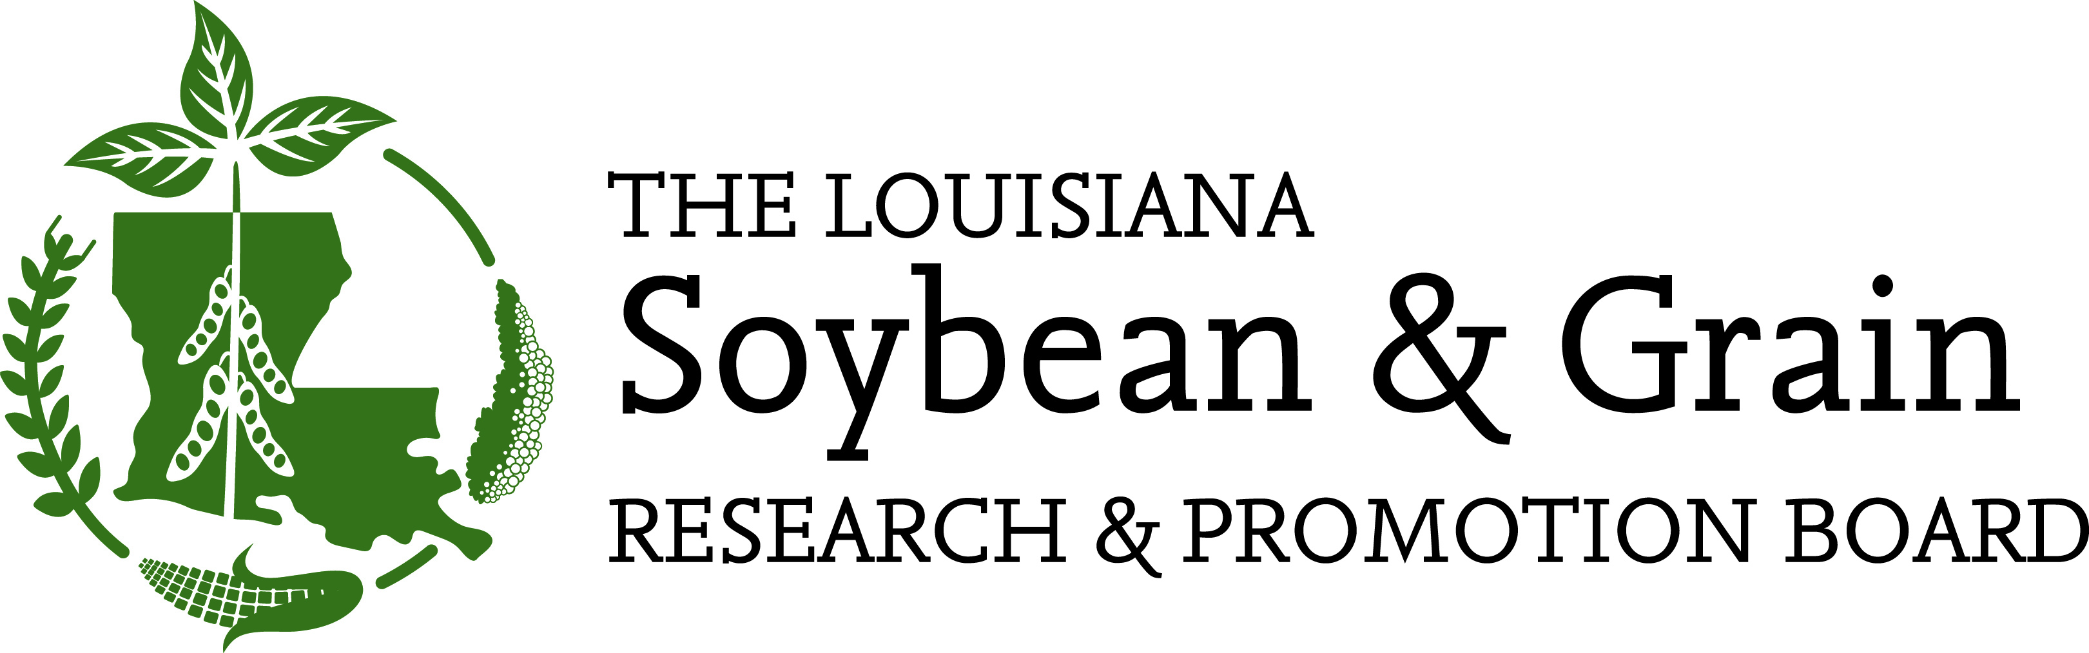
April 14, 2022

TO: All Louisiana Soybean Growers

CC: Louisiana Soybean and Grain Research and Promotion Board
Charles Cannatella, Joey Boudreaux, Scott Wiggers, Darrell Vandeven, Damian Glaser, Garrett Marsh, Burch Pierce, Joey Olivier, Kellon Lee, Wil Miller, Luke Sayes.

FROM: Charles Cannatella, Chairman

RE: Meeting Notice

A meeting of the Louisiana Soybean and Grain Research and Promotion Board (LSGRPB) has been scheduled as follows:
April 28, 2022
8:00 a.m.
Louisiana Farm Bureau – Board Room
9516 Airline Hwy.
Baton Rouge, LA 70815

The purpose for our meeting will be to review nominations to the United Soybean Board (USB). The LSGRPB nominates individuals to the US Secretary of Agriculture, USDA, for appointment to serve as a Board member on the USB. We encourage any soybean grower to come forward at this meeting that wishes to be considered to serve in this capacity to represent Louisiana soybean growers.

While the LSGRPB opened nominations at the January 18, 2022 meeting, to further implement their diversity plan, the vote on nominations was tabled to a later date. USDA-AMS has announced the application deadline of May 4, 2022 for final nominations from QSSBs; so the LSGRPB invites candidates of all backgrounds, soybean production practices, and ethnicities to consider being nominated as a Louisiana USB representative. Two nominees, a primary and secondary candidate, will be selected by the pool of nominees by the LSGRPB at this meeting.

If you have any questions or suggestions of soybean growers to be nominated, please contact Andy Brown, (225) 922-6209.

CC/ab

cc: Dr. Mike Salassi - LSU AgCenter
Todd Parker - Louisiana Department of Agriculture and Forestry
Mr. Bobby Skeen - Louisiana Cotton & Grain Association

